It’s A B.U.S.I. Day
Saturday, October 9, 2021| 10-2 p.m.
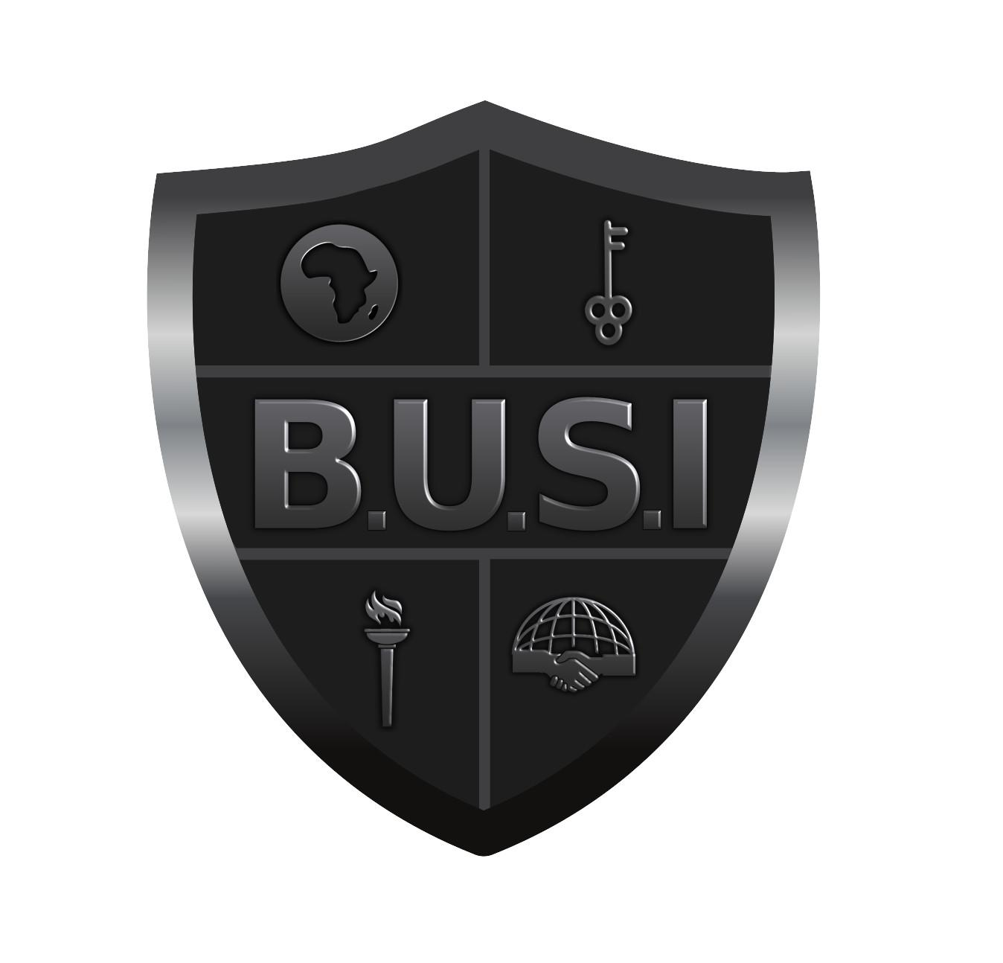
Battlefield Park| 953 W. Porter St. Jackson, MS 39204
Talent Show Participation Form
DEADLINE: October 1, 2021

Name of consenting adult ___________________________________________________________________

Address _____________________________________________________ City/State/Zip ________________

Cell Phone _________________________________________ Email Address __________________________

Best way to contact: Call • Text • Email •

Participants must be younger than age 18. Group performances may include up to 5 participants.

PLEASE INDICATE: Solo Performance • Group Performance •
Name & Age of Participant(s): ________________________________________________________________
_________________________________________________________________________________________
_________________________________________________________________________________________

If applicable, what is the name of your group? __________________________________________________

Type of act (singing, dancing, etc.) __________________________ Est. time of act ____________ (minutes)

Music to be used in performance _____________________________________________________________

________________________________ __________________________________
Performer #1 Signature Parent/Guardian #1 Signature

________________________________ __________________________________
Performer #2 Signature Parent/Guardian #2 Signature

________________________________ __________________________________
Performer #3 Signature Parent/Guardian #3 Signature

________________________________ __________________________________
Performer #4 Signature Parent/Guardian #4 Signature

________________________________ __________________________________
Performer #5 Signature Parent/Guardian #5 Signature

PLEASE NOTE: We will not offer auditions/rehearsals. We will not offer assistance for set-up.
Participants must bring their own music either on CD or phone. Music and performances must be clean, and no longer than 2 minutes. DEADLINE: October 1

If you have any question, for more information, or to return form, contact:

Rep. Zakiya Summers at (769) 224-0554 (text or call) or at electsummers@gmail.com

For more information about B.U.S.I., please visit BUSIconference.org.

